VENCREAT
AI Companion Hardware Platform
English product overview | configuration subject to technical review
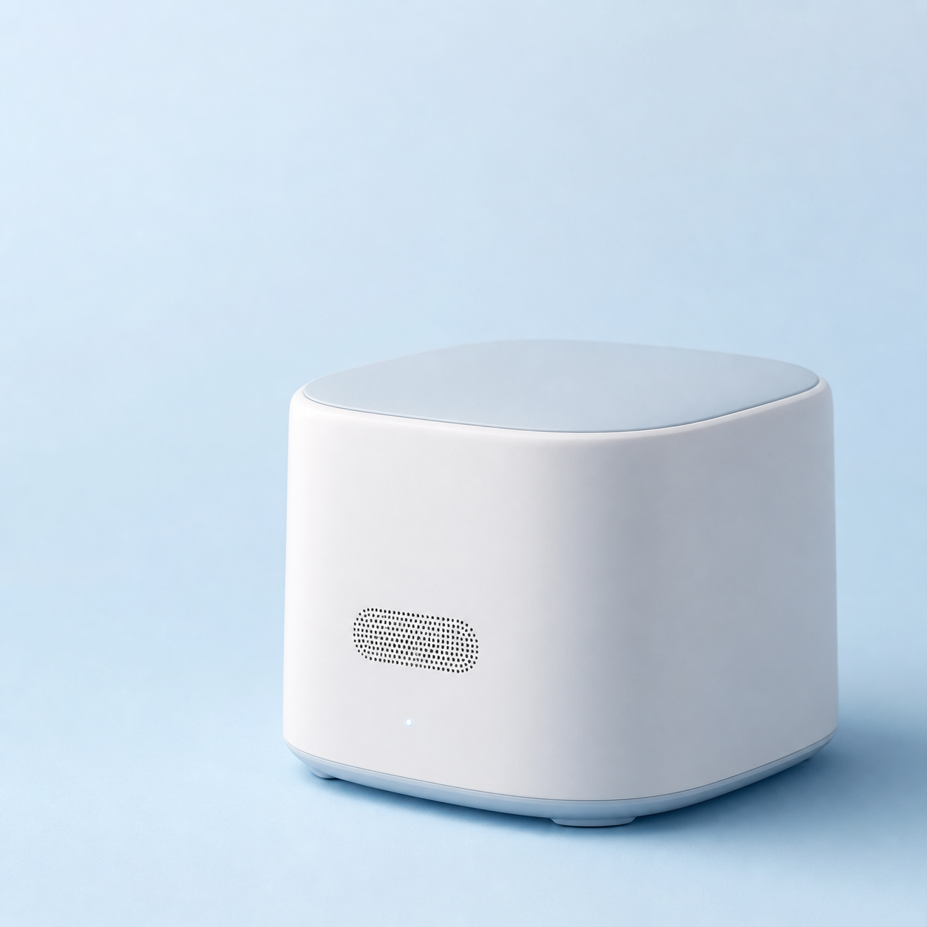
Purpose
A configurable hardware direction for connected companion products, including desktop companions, speaking-practice devices, interactive collectibles and electronic badges.
Configuration at a glance
Area | Project review focus
Connectivity | Wi-Fi or 4G is selected by deployment environment, account flow and support requirements.
Interaction | Microphones, speaker, status indication and optional display or sensors are evaluated against the intended user experience.
Power & enclosure | Charging approach, operating conditions, enclosure constraints and serviceability are confirmed for the target product.
Software readiness | Setup, recovery, content flow, account handling and remote support expectations are aligned before implementation.
Final specification | Processor, memory, network module, interfaces, certified components and production requirements are confirmed during technical review.
Before requesting a quotation
- Describe the usage scenario and expected deployment environment.
- Indicate whether Wi-Fi, 4G or both are required.
- List language, audio, battery, enclosure and service expectations.
- Share expected quantity and target project schedule.
Important note
This is a clean product overview, not a final technical specification. No processor, memory, battery, connectivity, certification or performance claim is made until the applicable configuration is reviewed and confirmed in writing.

